**Launching Limiter Tuning**

Done by Romain Nith on the 27/03/2017

Problem: Crossbow launches the ball too far (9 tiles without hitting the ball)

Solution: Add a stopper to reduce the elastic band travel

Procedure: Robot is positioned at 7 tiles from target. Add a Lego piece in on the crossbow’s barrel, launch and record distance. Increment the stopper until requirement is met.

|  |  |  |
| --- | --- | --- |
| Stopper position according to the exit of the launcher | Tile when it hits the floor | Hits target? |
| 0 | 9 | Yes (Direct hit) |
| 2 | 8 | No |
| 4 | 7 | No |
| 5 | 6 | Yes |
| 6 | 6 | Yes |
| 7 | 5 | No |

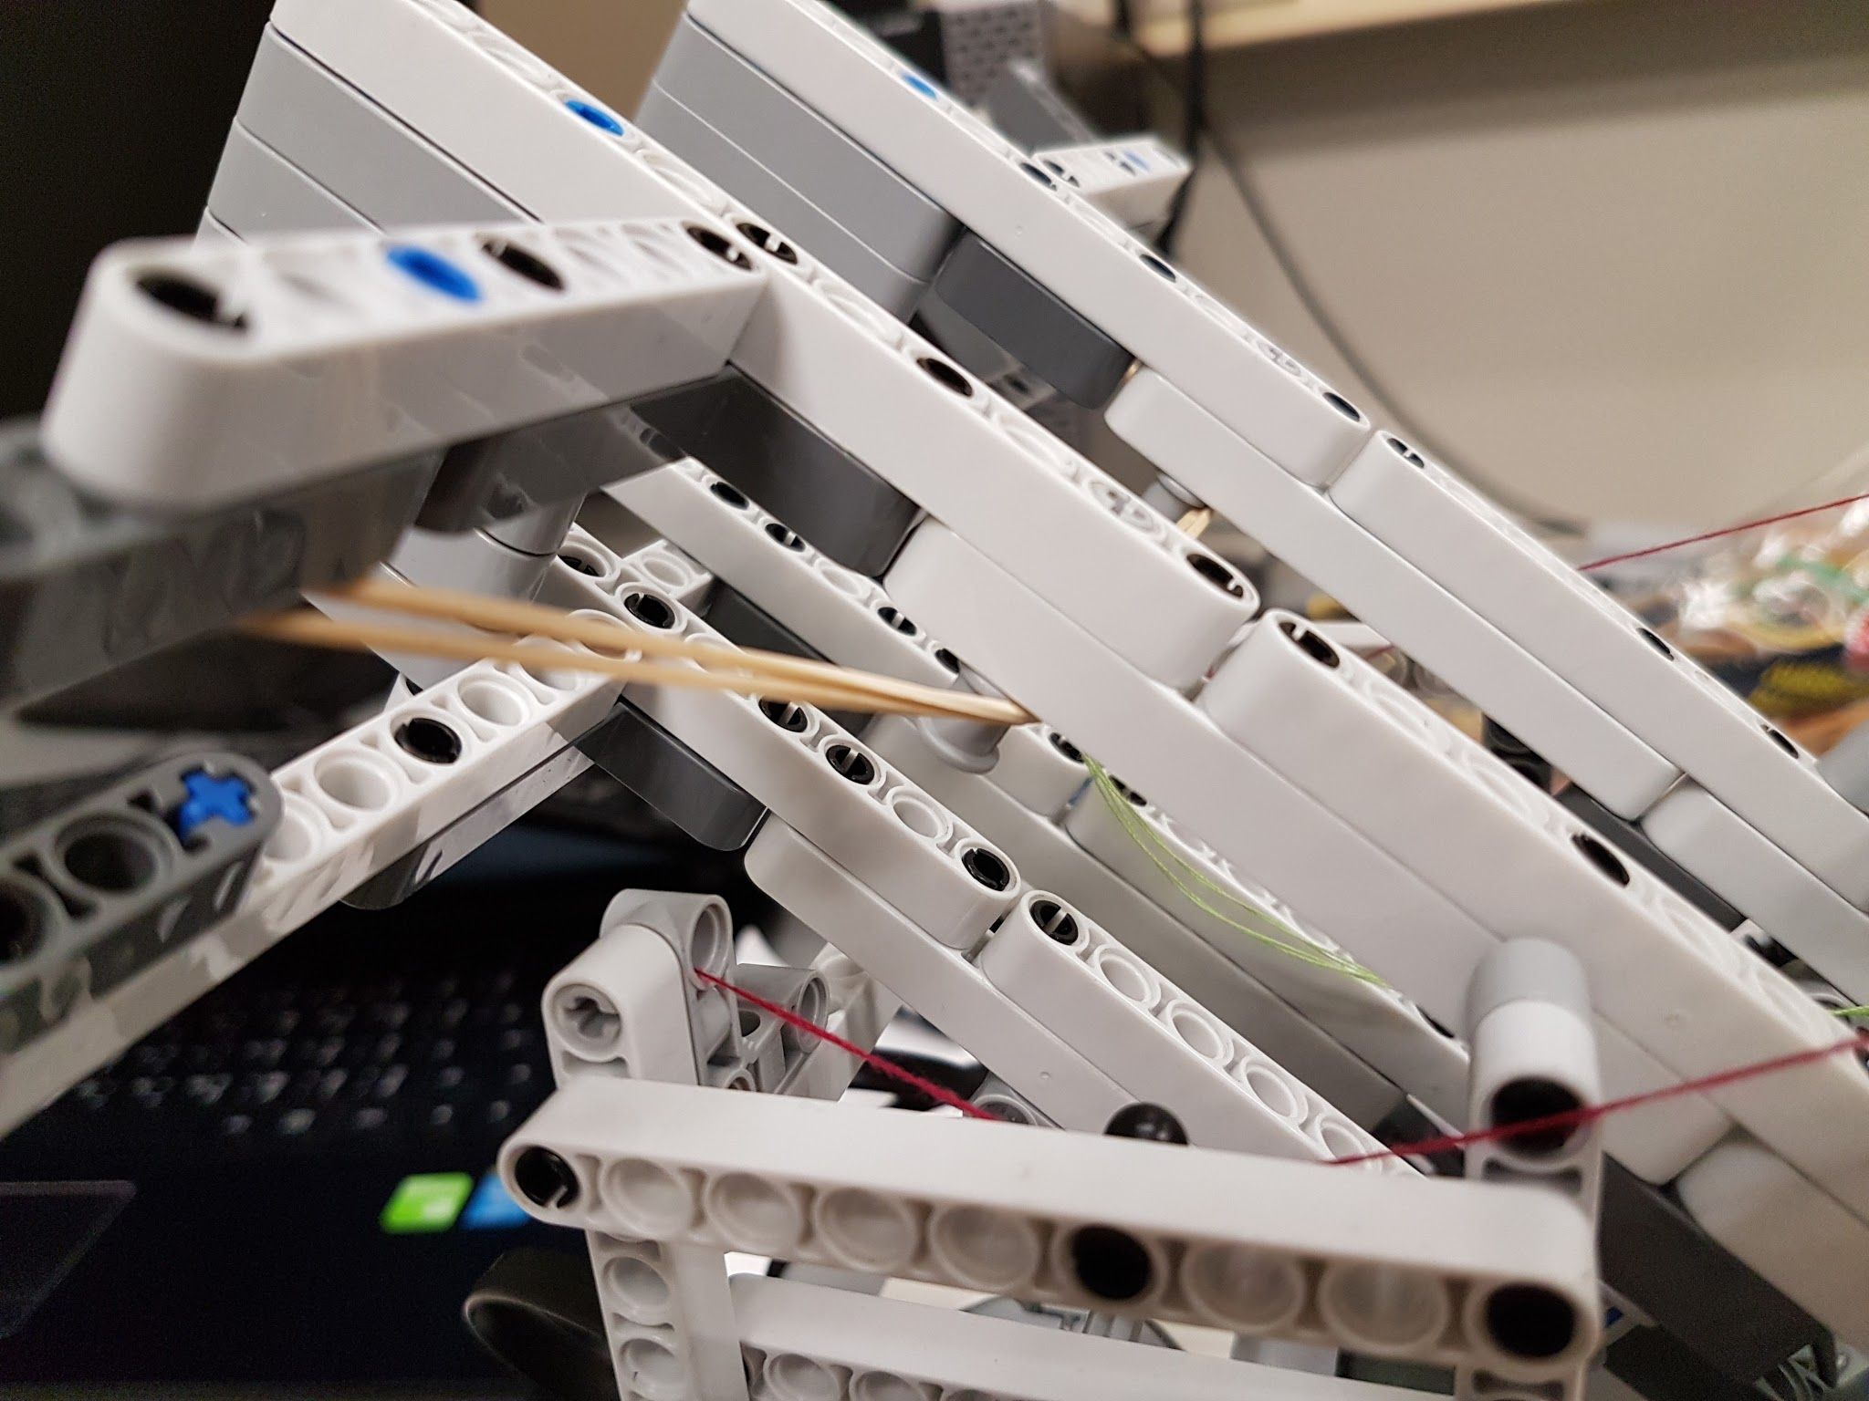

Result: At position 5 and 6, the stopper managed to launch the ball at the required distance while hitting the floor within specifications. To prevent losing too much momentum when hitting the floor, the stopper will be placed at position 5.

Remarque: To prevent damaging the stopper Lego part, we chose a small piece that has a 3 block height for stronger structure.